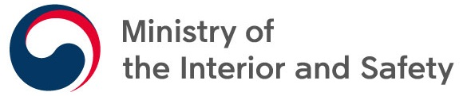
Press Release
Embargo & Release Date | October 19th, 2020
Division in charge | Digital Government Cooperation Division
Point of contact | Sung Joo SON (044-205-2781)  Seong Ju PARK (044-205-2787)

The Republic of Korea tops the OECD Digital Government Index
The Korean government plans to take this opportunity to further increase Korea’s digital competitiveness through the “Korean New Deal”.
The Ministry of the Interior and Safety (MOIS, Minister Chin, Young) announced that the Korean government ranked first on the 2019 Digital Government Index (DGI) launched by the Organisation for Economic Co-operation and Development (OECD) on October 16th.
The inaugural survey was conducted to measure countries’ progress towards higher levels of digital government maturity in 2018. 29 out of 37 OECD member countries and four non-member countries participated in the first survey. The survey assessed the progress of participating countries’ in six dimensions of the OECD Digital Government Policy Framework: digital by design, data-driven public sector, government as a platform, open by default, user-driven and proactiveness.
According to the Digital Government Index: 2019 results published by the OECD Secretariat, Korea tops the index with a composite score of 0.742 out of 1, followed by the United Kingdom (UK) with 0.736.
Among six dimensions, Korea’s efforts in using digital technologies in government service innovation and government reengineering through active communication with the public have helped Korea to rank first on “digital by design” and “open by default”. In addition, it ranks second on “government as a platform”, recognizing its efforts in breaking down silos among ministries and consolidating government systems.
On the other hand, the DGI left the Korean government room for improvement on the “proactiveness” dimension, with the score of 0.5 ranking 12th. The Korean government will accelerate implementation of the intelligent government initiatives of the Korean New Deal: National Strategy for a Great Transformation. These initiatives will enable the Korean government to become a truly digitally-enabled government equipped to provide proactive, customized services to the citizens.
Taking this opportunity, Korea plans to continue promoting various initiatives under the Korean New Deal, strengthening Korea’s digital competitiveness in the international arena.
Minister Chin emphasized that the result of this year’s DGI reflects well the Korean government’s digital government innovation efforts. He added that MOIS will continue driving the Korean digital government forward in the post-COVID-19 society.

